Project Implementation Plan: Customer Churn Prediction & Retention System
Role: Data Science Project Implementation Specialist
Framework: CRISP-DM (Cross-Industry Standard Process for Data Mining)
Timeline: 6 Weeks (25-Aug-2026 to 02-Oct-2026)

1. Executive Summary & Project Objectives
Customer attrition directly impacts monthly recurring revenue (MRR) and customer lifetime value (CLV). This project establishes an end-to-end Machine Learning pipeline and interactive application utilizing the CRISP-DM methodology to identify at-risk customers early and provide front-line teams with actionable insights.
- Primary Business Goal: Reduce quarterly customer churn by 15% through early-warning risk scoring and proactive retention campaigns.
- Primary Technical Goal: Develop, tune, and validate a supervised classification pipeline achieving ROC-AUC $≥$ 0.85 and Recall $≥$ 0.80 on the minority (churn) class.
- Operational Goal: Deliver a production-ready, interactive Streamlit web application supporting single-customer predictions, batch CSV scoring, and visual SHAP explainability.

2. Project Scope & Key Stakeholder Matrix
In-Scope Deliverables:
- Historical data extraction, cleaning, exploratory data analysis (EDA), and data profiling.
- Feature engineering (customer tenure, payment/contract patterns, usage decay, support ticket frequency).
- Model development, hyperparameter tuning, and cross-validation across baseline and ensemble models (Logistic Regression, Random Forest, XGBoost).
- Explainability analysis using SHAP (SHapley Additive exPlanations) and feature importance rankings.
- Interactive web application and batch inference interface built with Streamlit, featuring real-time prediction inputs, CSV upload capabilities, and model monitoring dashboards.
Out-of-Scope:
- Native mobile application development (iOS/Android).
- Direct financial restructuring, automated discount issuance, or billing policy alterations.
Stakeholder Alignment Matrix:
Stakeholder Role | Key Responsibilities | Primary Success Metric
Project Sponsor (CCO / Head of Retention) | Strategic direction, business sign-off, resource allocation | Measurable churn reduction and revenue retention
Lead Data Scientist | Technical governance, model architecture review, leakage prevention | High generalization, robust metrics (ROC-AUC $≥$ 0.85)
Data Science Implementation Specialist | Pipeline execution, EDA, feature engineering, model training, documentation | Milestone delivery, reproducible clean code
MLOps / App Developer | Streamlit UI architecture, containerization (Docker), state management | Fast UI response times, seamless batch inference
Retention Operations Team | Operational execution of retention calls and outreach | Clear risk score interpretability and ease of tool use

3. Project Schedule & Milestone Breakdown (6-Week Timeline)
PHASE / ACTIVITY | DATES | DURATION | KEY DELIVERABLES | STATUS
Week 1: Strategic Planning & Project Scoping | 25-Aug – 29-Aug | 5 Days | Project charter, KPIs, stakeholder matrix, risk plan, visual Gantt chart | 100%
Week 2: Data Acquisition & Preparation | 30-Aug – 04-Sep | 6 Days | 3 public datasets, data profiling, cleaning & transformation workflows | 0%
Week 3: Model Development & Validation | 05-Sep – 11-Sep | 7 Days | Feature engineering, XGBoost/RF models, hyperparameter tuning, metrics | 0%
Week 4: Streamlit Deployment & UI Integration | 12-Sep – 18-Sep | 7 Days | Interactive Streamlit web app, batch CSV scoring, embedded SHAP plots | 0%
Week 5: Performance Evaluation & Optimization | 19-Sep – 25-Sep | 7 Days | Drift tracking (Evidently AI), latency benchmarking, retraining triggers | 0%
Week 6: Final Documentation & Handover | 26-Sep – 02-Oct | 7 Days | Capstone project report, user runbooks, lessons learned, final sign-off | 0%

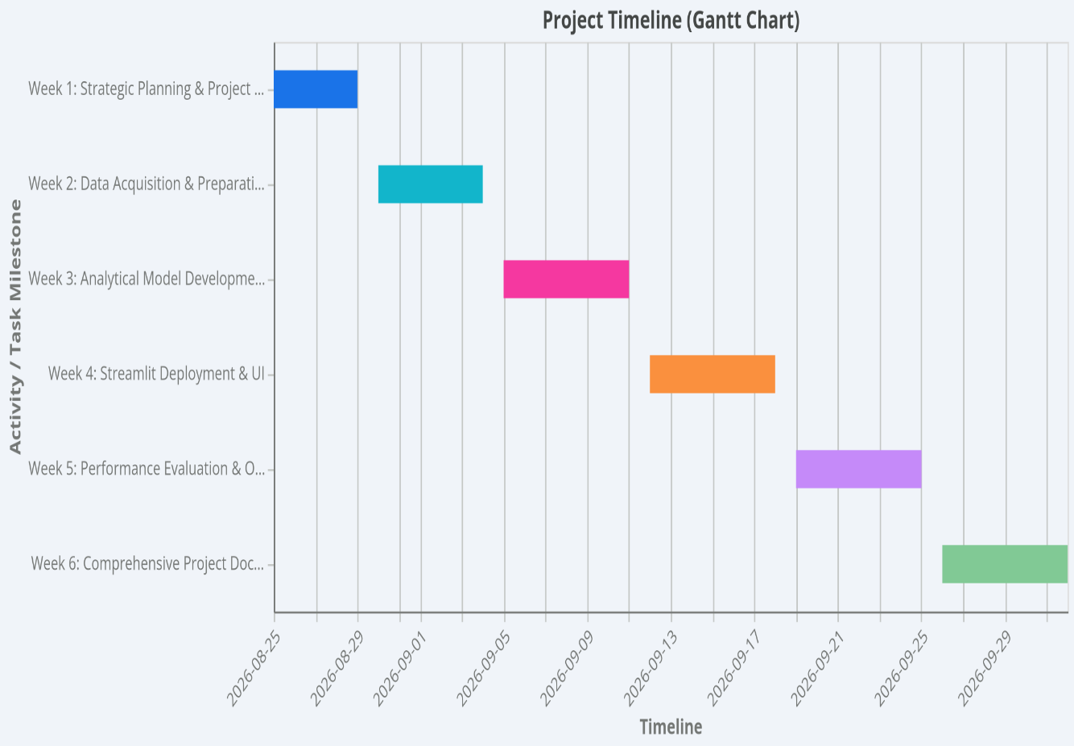
4. Visual Gantt Chart

5. Resource Allocation Matrix
Role | Primary Responsibilities | Core Technology Stack
Data Science Specialist | Scoping, EDA, feature engineering, model training, hyperparameter tuning, SHAP explainability | Python, Pandas, Scikit-learn, XGBoost, SHAP, Jupyter
Data Engineer | Data extraction, ETL pipelines, schema validation, data warehousing | SQL, PostgreSQL, Snowflake, PySpark
MLOps / App Developer | Streamlit UI architecture, model artifact packaging, containerization, session state management | Streamlit, Docker, GitHub, Joblib/Pickle
Business / BI Analyst | Stakeholder requirements, KPI reporting, user acceptance testing (UAT) | Tableau, Power BI, Excel

6. Risk Management & Mitigation Framework
Identified Risk | Severity | Likelihood | Mitigation Strategy
Class Imbalance | High | High | Implement SMOTE, class weighting (scale_pos_weight), and evaluate performance using PR-AUC and Recall rather than standard accuracy.
Data Leakage in Preprocessing | Critical | Medium | Enforce strict time-based train/test splitting; encapsulate all imputations, scalers, and encoders inside Scikit-learn ML Pipelines.
Model & Concept Drift | Medium | High | Integrate automated statistical drift monitoring (Evidently AI) and configure scheduled monthly retraining protocols.
Low End-User Adoption | Medium

